

**Name of Group Members** **: Chan Keen Keet (TP037812)**

**Ng Wen Yang (TP037400)**

**Lee Kang Wei (TP037224)**

**Module Name:** System Development Project

**Module Code: AAPP006-4-2 SDP**

**Assignment Title:** Group Assignment

**Lecturer’s Name:** Mr Shum Yew Mun

**Due Date:** 8th November2016

Table of Contents

2.0 Workload matrix 2

3.0 Introduction 6

3.1 Project Background 6

3.2 Problem Context 6

3.3 Project Solution 6

3.4 Project Scope 7

3.5 Project Objectives 7

4.0 Project Plan 8

4.1 Methodology 8

4.2 Project Gantt Chart 10

5.0 Hierarchy chart 11

6.0 Context Diagram and Date Flow Diagrams 14

6.1 Context Diagram 14

6.2 Level 0 Diagram 15

6.3 Level 1 Diagram 16

7.0 Data Dictionary 17

7.1 Data Dictionary for External Entity 17

7.2 Data Dictionary for Process 18

7.3 Data Dictionary for Data Flow 21

7.4 Data Dictionary for Data Store 28

8.0 Entity Relationship Diagram 31

9.0 Pseudocode 32

10.0 Preliminary Screens Design 40

11.0 Preliminary Report Design 61

12.0 Test Plan 66

13.0 Conclusion 81

13.1 Perceived Assumption 81

13.2 Perceived Limitations 82

13.3 Perceived Enhancement 83

14.0 References 84

15.0 Appendix 85

# 2.0 Workload matrix

|  |  |  |  |  |  |
| --- | --- | --- | --- | --- | --- |
| **SDP Workload Matrix (Partial Document)** | |  |  |  |  |
|  |  |  |  |  |  |
| **No.** | **Name** | **Student ID** |  |  |  |
| *1* | *Chan Keen Keet* | *TP037812* |  |  |  |
| *2* | *Ng Wen Yang* | *TP037400* |  |  |  |
| *3* | *Lee Kang Wei* | *TP037224* |  |  |  |
|  |  |  |  |  |  |
| **GROUP COMPONENT (DESIGN DOCUMENTATION)** | | |  |  |  |
| **No.** | **Chapter** | **Student Name** | | | **Total %** |
| ***Chan Keen Keet*** | ***Ng Wen Yang*** | ***Lee Kang Wei*** |
| 1 | Table of Content |  |  | 100 | 100 |
| 2 | Acknowledgment (Optional) |  |  |  | 0 |
| 3 | Abstract (Optional) |  |  |  | 0 |
| 4 | Workload matrix |  | 100 |  | 100 |
| 5 | Introduction • Project Background • Problem Context • Proposed Solution • Project Scope • Project Objectives | 33.33 | 33.33 | 33.33 | 99.99 |
| 6 | Project Plan • System Development Methodology • Project Gantt Chart | 33.33 | 33.33 | 33.33 | 99.99 |
| 7 | Test Plan | 33.33 | 33.33 | 33.33 | 99.99 |
| 8 | Conclusion • Perceived Assumptions • Perceived Limitations • Perceived Enhancements | 33.33 | 33.33 | 33.33 | 99.99 |
| 9 | References | 100 |  |  | 100 |
| 10 | Appendix • Weekly Report / Minutes of Meeting | 33.33 | 33.33 | 33.33 | 99.99 |
|  | **TOTAL %** | 33.333333 | 33.33333333 | 33.33333333 | 799.95 |
|  |  |  |  |  |  |

|  |  |  |  |  |  |
| --- | --- | --- | --- | --- | --- |
|  |  |  |  |  |  |
| **INDIVIDUAL COMPONENT (DESIGN PRESENTATION)** | | |  |  |  |
| **No.** | **Chapter** | **Student Name** | | | **Total %** |
| ***Chan Keen Keet*** | ***Ng Wen Yang*** | ***Lee Kang Wei*** |
| 1 | System Hierarchy Chart |  |  |  | 0 |
| 2 | Context Diagram & DFD |  |  |  | 0 |
| 3 | Data Dictionary |  |  |  | 0 |
| 4 | Entity Relationship Diagram |  |  |  | 0 |
| 5 | Pseudocode (or Flow Chart) |  |  |  | 0 |
| 6 | Preliminary Screen Design |  |  |  | 0 |
| 7 | Preliminary Report Design |  |  |  | 0 |
|  | **TOTAL %** | #DIV/0! | #DIV/0! | #DIV/0! | 0 |
|  |  |  |  |  |  |
|  |  |  |  |  |  |
|  |  |  |  |  |  |
|  |  |  |  |  |  |
|  |  |  |  |  |  |

# 3.0 Introduction

## 3.1 Project Background

My Schedule is a software organization that offer timetabling solutions for Asean Pacifist University (APU). APU has been facing problem with their timetabling management where it is a critical problem for a university. My Schedule development team has been assigned to develop a timetable scheduling system for APU. APU is a private university located in Bukit Jalil. APU is opened from 8.00 am to 9.00 pm. The current timetable scheduling system that APU is using is spreadsheet to manually assign lecturers to intakes and allocate the classes of every module.

## 3.2 Problem Context

Due to the large variety of course that are available for each intake, the process of timetable scheduling is difficult to solve. Each and every time when the timetable needs to be arranged, it is time consuming and high manpower are required. Time is wasted when manually scheduling the timetable especially with pen and spreadsheet system. Confusions and clashes between classes may occurs when manually scheduling the timetable. The current timetabling system shows that it is not efficient and the probability of mistakes may occur is high.

## 3.3 Project Solution

The development team has proposed solutions to solve the problems being faced by APU when scheduling the timetable. The solution to solve those problems is to develop a new timetable scheduling system which helps the university to generate timetables with efficient usage of resources and facilities. This system also allows APU to generate a timetable which has reasonable duration of break time between classes every day. It also allows lecturer and students to reserve classes or activities easily by using the system.

## 3.4 Project Scope

APU currently has 50 classroom in the university compound which includes computer labs, engineering labs, and auditoriums. APU is currently offering 5 courses for diploma students and 15 courses for degree students and 4 intakes will be recruited each year. The duration of diploma courses are 5 semester and 14 weeks for each semester. For degree level, there are 2 semesters and 14 weeks for each semester. The classes started from 8.30 am until 5.30 pm. After 5.30 pm, APU is still opened until 9.00 pm.

## 3.5 Project Objectives

This project is to help APU to have a better timetabling system, which is by using the timetable scheduling system. One of the objectives of this project is to help APU to increase their efficiency when generating a timetable. Another objective is to help APU to have more functions in their timetabling system where it does not only able generate timetable, but it also allows users like lecturers and students to reserve the available classroom by using this timetable scheduling system. Furthermore, it also reduce the manpower needed to generate a timetable with reasonable break time.

# 4.0 Project Plan

## 4.1 Methodology

System Planning Phase

System Analysis Phase

System Design Phase

System Implementation Phase

System, Security and Support Phase

In the system planning phase, the first action to be taken is problem identification. The problems faced by APU are the slow and inefficient timetable scheduling method, confusions and clashes between classes that may occurs, and high manpower needed to arrange timetable each time. The next step is to define the project scope. The number of classes, courses details, intake details, courses details and size of classroom can be obtained from APU admin and management. The project objectives are gathered by the development team based on the problems that are identified in the current manual timetabling system of APU. The tasks and duty are assigned accordingly to the members of the development team to fulfill the objectives and solve the problems.

In the system analysis phase, the requirements of this project are obtained from the APU management department and analyzed. After the analysis, the development team will create and build a logical model of timetable scheduling system based on the requirements that are gathered.

In the system design phase, the development team has to determine the required input and required output for the proposed system in the data and processes design session. After gathering the required input and output, physical model will be created based on the gathered input and output. The physical model includes context diagram, data flow diagram and screen design. After that, based on the physical models that are created, a prototype design of the proposed system is created. It is for testing purpose and to check any errors or bug. Report design is created after the prototype is done. It is a draft sample design of the output.

In the system implementation phase, required hardware installation for the new timetable scheduling system is implemented. Example of hardware that are required for this new system are Personal Computer (PC) that contains mouse, keyboard and monitors to control and run this system.Then, the proposed system of APU is to be coded and documented. The code snippets are then presented for the users of APU about the created system. When the new system is presented, the system is tested and it allow the users of APU to use and try the system personally. This is to find out whether there is any bug or error. After testing, the new system is installed and ready to be use. Besides that, the development team of the new system also provides user training of this system.

In the last phase which is the system, security and support, the development team has provide end user support which is by having a guide or user manual for users which are specialized in using the timetable system. Furthermore, hardware services is also provided where developers will have the hardware repaired or replaced when there is any malfunctioning of the system occurs due to hardware problem. Lastly, maintenance of the system is provided where it will have services or updates for the timetable scheduling system.

## 4.2 Project Gantt Chart

# 5.0 Hierarchy chart

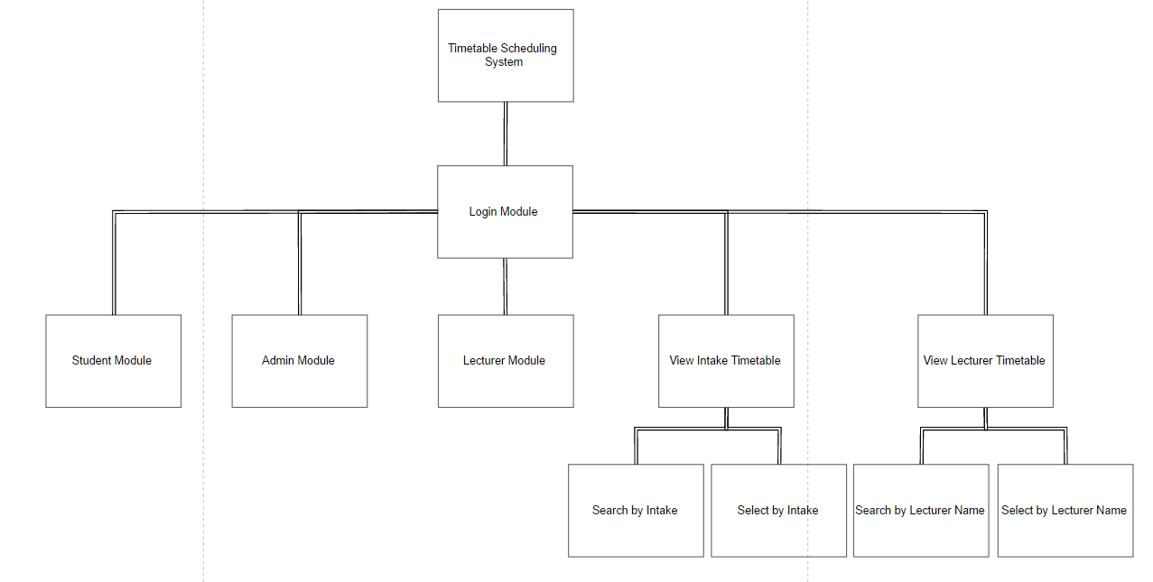

Login Module

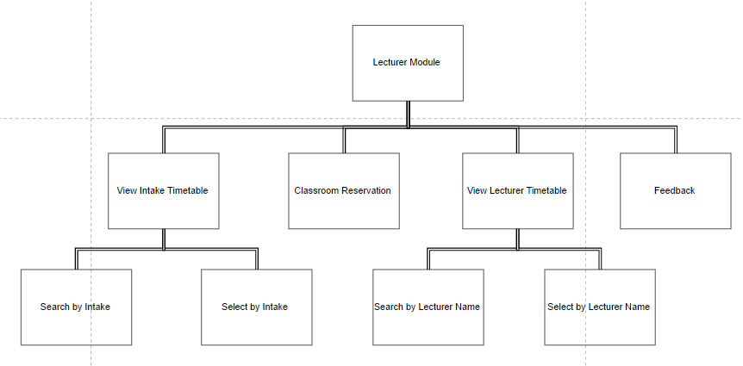

Lecturer Module

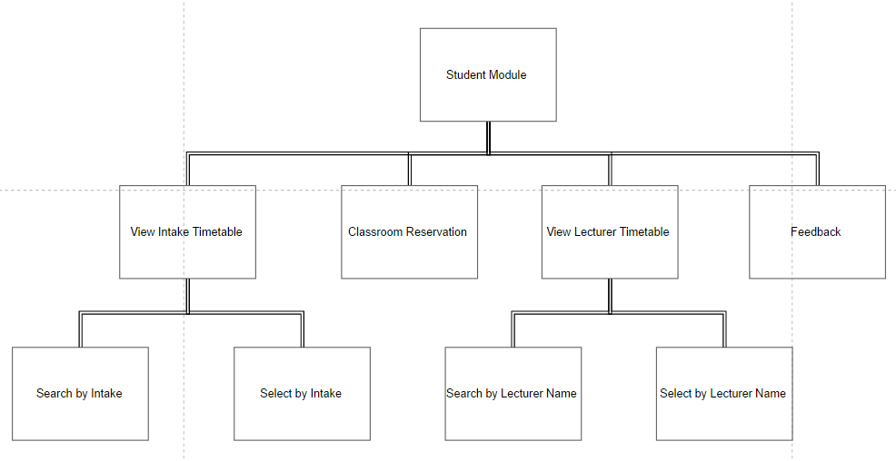

Student Module

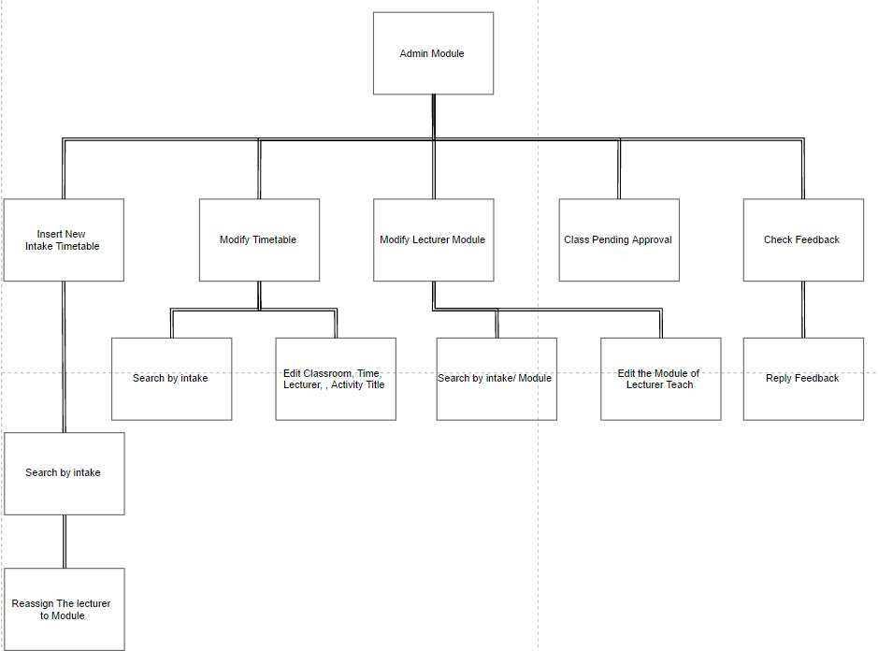Admin Module

# 6.0 Context Diagram and Date Flow Diagrams

## 6.1 Context Diagram

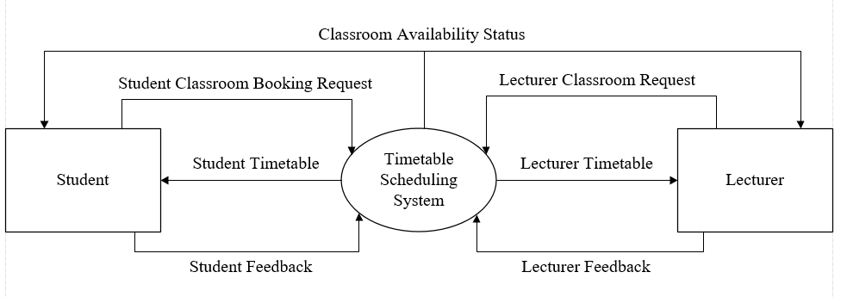

## 6.2 Level 0 Diagram

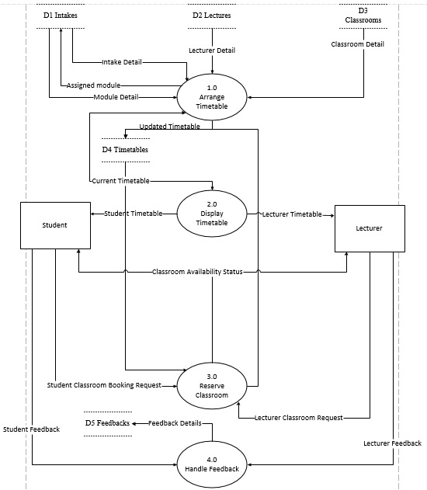

## 6.3 Level 1 Diagram

# 7.0 Data Dictionary

## 7.1 Data Dictionary for External Entity

|  |  |
| --- | --- |
| Name | Student |
| Description | Student of the university who uses the timetable scheduling system to view timetables and reserve classroom. |
| Input data flows | Student Timetable, Classroom Availability Status, Intake Timetable |
| Output data flows | Student Classroom Booking Request, Student Feedback |

|  |  |
| --- | --- |
| Name | Lecturer |
| Description | Lecturer of the university who uses the timetable scheduling system to view timetables and reserve classroom. |
| Input data flows | Lecturer Timetable, Classroom Availability Status |
| Output data flows | Lecturer Classroom Request, Lecturer Feedback |

## 7.2 Data Dictionary for Process

|  |  |
| --- | --- |
| Name | 1.1 Insert New Intake |
| Description | This process is to assign lecturer to the modules of the new intake and then generate classes based on the starting and ending of the new intake |
| Input data flows | Module Detail, Intake Detail, Lecturer Detail, Classroom Detail, Current Timetable |
| Output data flows | Assigned Module, Updated Timetable |
| Process description | Refer to the Pseudo code InsertNewIntake |

|  |  |
| --- | --- |
| Name | 1.2 Modify Timetable |
| Description | This process is to modify the timetable where lecturer, date and time can be change when it is needed |
| Input data flows | Intake Detail, Current Timetable |
| Output data flows | Modified Timetable |
| Process description | Refer to the Pseudo code ModifyTimetable |

|  |  |
| --- | --- |
| Name | 2.1 Display Intake Timetable |
| Description | This process is to display timetable of the selected intake from the current timetable |
| Input data flows | Current Timetable |
| Output data flows | Intake Timetable |
| Process description | Refer to Pseudo code of DisplayIntakeTimetable |

|  |  |
| --- | --- |
| Name | 2.2 Display Lecturer Timetable |
| Description | This process is to display timetable of the selected lecturer from the current timetable |
| Input data flows | Current Timetable |
| Output data flows | Lecturer Timetable |
| Process description | Refer to Pseudo code of DisplayLecturerTimetable |

|  |  |
| --- | --- |
| Name | 3.0 Reserve Classroom |
| Description | This process is for student and lecturer to reserve the classroom that is available by sending classroom request to the admin and pending for approval. |
| Input data flows | Current Timetable, Student Classroom Booking Request, Lecturer Classroom Request |
| Output data flows | Classroom Availability Status, Updated Timetable |
| Process description | Refer to Pseudo code of ReserveClassroom(user) section |

|  |  |
| --- | --- |
| Name | 4.0 Handle Feedback |
| Description | This process is to receive feedback given by students and lecturer and it is stored and the database is shared with another department |
| Input data flows | Student Feedback, Lecturer Feedback |
| Output data flows | Feedback Details |
| Process description | Refer to Pseudo code of CheckFeedback |

## 7.3 Data Dictionary for Data Flow

|  |  |
| --- | --- |
| Name | Intake Detail |
| Description | The intake details that are obtained from the intake data store which is a shared database |
| Origin/Source | D1 Intakes |
| Destination | 1.1 Insert New Intake |
| Data Structure | Lecturer ID, Lecturer Name, Module, Date, Intake Code, Level, Time, Module Code, Classroom ID |

|  |  |
| --- | --- |
| Name | Module Detail |
| Description | Module details of the intake that are obtained from the intakes data store which is a shared database |
| Origin/Source | D1 Intakes |
| Destination | 1.1 Insert New Intake |
| Data Structure | Module Name, Module ID, Intake Code, Classroom ID |

|  |  |
| --- | --- |
| Name | Lecturer Detail |
| Description | Lecturer details are obtained from the lectures data store which is a shared database |
| Origin/Source | D2 Lectures |
| Destination | 1.1 Insert New Intake |
| Data Structure | Lecturer ID, Lecturer Name, Intake, Module, Classroom ID |

|  |  |
| --- | --- |
| Name | Classroom detail |
| Description | Classroom details that are obtained from classroom data store and it is a shared database |
| Origin/Source | D3 Classrooms |
| Destination | 1.1 Insert New Intake |
| Data Structure | Classroom ID, Intake Code, Facility |

|  |  |
| --- | --- |
| Name | Updated Timetable |
| Description | Timetable will be updated when new intake is inserted into the timetable |
| Origin/Source | Insert New Intake |
| Destination | D4 Timetables |
| Data Structure | Module ID, Module Name, Time Slot, Intake Code, Date, Classroom ID, Lecturer Name |

|  |  |
| --- | --- |
| Name | Current Timetable |
| Description | The current timetable are ready to be modified and insert as a new intake. If no modification is made, the current timetable will be the latest timetable and is ready to be display for student and lecturer. |
| Origin/Source | D4 Timetables |
| Destination | 1.1 Insert New Intake, 1.2 Modify Timetable, 2.1 Display Intake Timetable, 2.2 Display Lecturer Timetable |
| Data Structure | Module ID, Module Name, Time Slot, Intake Code, Date, Classroom ID, Lecturer Name |

|  |  |
| --- | --- |
| Name | Modified Timetable |
| Description | the latest timetable that is modified by admin, is then save it in the timetable database. |
| Origin/Source | 1.2 Modify Timetable |
| Destination | D4 Timetables |
| Data Structure | Module ID, Module Name, Time Slot, Intake Code, Date, Classroom ID, Lecturer Name |

|  |  |
| --- | --- |
| Name | Intake Timetable |
| Description | Timetable of a particular intake that shows the classes information. It can be viewed by the students and lecturers |
| Origin/Source | 2.1 Display Intake Timetable |
| Destination | Student |
| Data Structure | Module ID, Module Name, Intake Code, Date, Classroom ID, Lecturer Name |

|  |  |
| --- | --- |
| Name | Lecturer Timetable |
| Description | Timetable that contains information of particular lecturer. It can be viewed by student and other lecturer as well |
| Origin/Source | 2.2 Display Lecturer Timetable |
| Destination | Lecturer |
| Data Structure | Module ID, Module Name, Intake Code, Date, Classroom ID, Lecturer Name |

|  |  |
| --- | --- |
| Name | Classroom Availability Status |
| Description | The status of a classroom that showing whether it is available or occupied |
| Origin/Source | 3.0 Reserve Classroom |
| Destination | Student, Lecturer |
| Data Structure | Facility, Classroom ID, Status |

|  |  |
| --- | --- |
| Name | Student Classroom Booking Request |
| Description | The request of student to reserve the classroom for activity |
| Origin/Source | Student |
| Destination | 3.0 Reserve Classroom |
| Data Structure | Date, Classroom ID, Time Slot, Classroom Size, Reference Number, Purpose, Description, Student ID |

|  |  |
| --- | --- |
| Name | Lecturer Classroom Request |
| Description | The request of lecturer to reserve classroom for activity or class |
| Origin/Source | Lecturer |
| Destination | 3.0 Reserve Classroom |
| Data Structure | Date, Classroom ID, Time Slot, Classroom Size, Reference Number, Purpose, Description, Lecturer ID |

|  |  |
| --- | --- |
| Name | Student Feedback |
| Description | Feedback that is sent by the student regarding the system |
| Origin/Source | Student |
| Destination | 4.0 Handle Feedback |
| Data Structure | Description, Student ID, Lecturer ID, Reference ID, Categories |

|  |  |
| --- | --- |
| Name | Lecturer Feedback |
| Description | Feedback that is sent by the lecturer regarding the system |
| Origin/Source | Lecturer |
| Destination | 4.0 Handle Feedback |
| Data Structure | Description, Student ID, Lecturer ID, Reference ID, Categories |

|  |  |
| --- | --- |
| Name | Feedback Details |
| Description | Feedback that is collected from lecturer or student is stored in feedback data store which is a shared database |
| Origin/Source | 4.0 Handle Feedback |
| Destination | D5 Feedbacks |
| Data Structure | Description, Student ID, Lecturer ID, Reference ID, Categories |

## 7.4 Data Dictionary for Data Store

|  |  |
| --- | --- |
| Name | D1 Intakes |
| Description | Store all intake and module details and it is a shared database |
| Input data flows | Assigned Module |
| Output data flows | Intake Detail, Module Detail |
| Data Structure | Date, Time Slot, Module Name, Module ID, Intake Code, Classroom |

|  |  |
| --- | --- |
| Name | D2 Lectures |
| Description | Store all lecturer details that is needed to arrange the timetable and it is a shared database |
| Input data flows | - |
| Output data flows | Lecturer Detail |
| Data Structure | Lecturer Name, Lecturer ID, Module ID, Module Name, Intake Code |

|  |  |
| --- | --- |
| Name | D3 Classrooms |
| Description | Store all types of classrooms details like labs and auditoriums. It is also a shared database |
| Input data flows | - |
| Output data flows | Classroom Detail |
| Data Structure | Classroom ID, Facility, Classroom Size, Status, |

|  |  |
| --- | --- |
| Name | D4 Timetables |
| Description | Store all latest timetables details |
| Input data flows | Updated Timetable, Modified Timetable |
| Output data flows | Current Timetable |
| Data Structure | Date, Classroom ID, Time Slot, Module, Lecturer Name, Intake Code, Module ID |

|  |  |
| --- | --- |
| Name | D5 Feedbacks |
| Description | Store all feedbacks details from lecturer and students. It is a shared database |
| Input data flows | Feedback Details |
| Output data flows | - |
| Data Structure | Description, Student ID, Lecturer ID, Reference ID, Categories |

# 8.0 Entity Relationship Diagram

ERDv1.png

# 9.0 Pseudocode

**LoginPage**

START

WHILE user does not terminate the program

GET userOption from user

CASE userOption OF

lecturerTimetable : CALL DisplayLecturerTimetable

intakeTimetable : CALL DisplayIntakeTimetable

Login :

GET loginID from user

GET loginPassword from user

GET userList from database

FOR each user in userList

IF loginID EQUALS TO User.ID THEN

IF loginPassword EQUALS TO user.Password THEN

CASE user.type OF

student : CALL MainMenu with (user)

lecturer : CALL MainMenu with (user)

admin : CALL AdminMainMenu (user)

END CASE

BREAK

ELSE

DISPLAY errorMessage

BREAK

END IF

END IF

IF User is last user THEN

DISPLAY errorMessage

END IF

END FOR

END CASE

END WHILE

END

**MainMenu(user)**

START

WHILE the user is not logged out

GET selection from user

CASE selection OF

courseTimetable : CALL DisplayCourseTimetable

lecturerTimetable : CALL DisplayLecturerTimetable

classroomReservation : CALL ReserveClassroom with (user)

feedback : CALL SumbitFeedback with (user)

logout : END

END CASE

END WHILE

**AdminMainMenu(user)**

START

GET selection from user

CASE selection OF

insertNewIntakeTimetable : CALL InsertNewIntake

modifyTimetable : CALL ModifyTimetable

modifyModuleLecturer : CALL ModifyModuleLecturer

classPendingApproval : CALL ApproveClassPending

checkFeedback : CALL CheckFeedback

logout : END

END CASE

**DisplayIntakeTimetable**

START

GET timetableList from database

GET intakeCode from user

GET currentTime from system

DISPLAY timetable filter by intakeCode and currentTime from timetableList

END

**DisplayLecturerTimetable**

START

GET timetableList from database

GET lecturer from user

GET currentTime from system

DISPLAY timetable filter by lecturer and currentTime from timetableList

END

**ReserveClassroom(user)**

START

GET userType from user.type

CASE userType OF

lecturer : fill purposeOption with (extra class, class replacement)

student : fill purposeOption with (student activity)

END CASE

GET date from user

validate whether date input is empty input

GET timetableList form database

SET availableClassroomList as timetableList filter by time and empty timeslot

DISPLAY availableClassroomList

GET timeslotSelection from user

validate whether timeslotSelection input is empty input

GET purposeOption from user

validate whether purposeOption input is empty input

GET descriptionText from user

GET confirmation from user

SAVE classroomReservationRequest to database with (timeslotSelection, purposeOption, user)

END

**SubmitFeedback(user)**

START

GET category from user

GET feedbackText from user

GET confirmation from user

GET referenceNumber from database

INCERMENT referenceNumber in database

SAVE feedback to database including user.ID, user.name, user.type, datetime

END

**InsertNewIntake**

START

GET intakeList form database

GET intakeSelection from user

validate whether intakeSelection input is empty input

GET intakeStartingDate from database

GET intakeEndingDate from database

GET lecturerList from database

GET ModuleList from database

FOR each module in the ModuleList

FOR each lecturer in lecturerList

IF lecturer can teach the module THEN

CALL lecturerList.sortByWorkload

CALL module.assignLecturer with (lecturer)

BREAK

END IF

END FOR

END FOR

DISPLAY module with lecturer

GET moduleLecturerChange from user

GET confirmation from user

SAVE assignedModule to database

GET timetableList from database

GET maxDayTeachingHour

GET maxDayLearningHour

FOR all module in moduleList

FOR all timeslot in timetableList

IF timeslot.lecturer.dayTeachingHour with (timeslot) < maxDayTeachingHour AND timeslot.intakeDayLearningHour with (timeslot) < maxDayLearningHour AND timeslot.lecturer.isAvailable with (timeslot) AND timeslot.noDuplicatedIntakeModule with (timeslot) AND timeslot.NoLargeGapBetweenClass with (timeslot) THEN

CALL module.assignTimeslot with (timeslot)

BREAK

END IF

IF reached last timeslot THEN

Append module to exceptionList

DISPLAY warningMessage

END IF

END FOR

END FOR

DISPLAY exceptionList

GET classroomList from database

CALL classroomList.sortBySize

CALL timetableList.sortByStudentSize

FOR every timeslot in timetableList

FOR every classroom in classroomList

IF timeslot.studentSize < classroom.size AND THEN

CALL timeslot.assignClassroom with (classroom)

BREAK

END IF

IF reached last timeslot THEN

Append timeslot to exceptionList

DISPLAY warningMessage

END IF

END FOR

END FOR

DISPLAY exceptionList

SAVE timetable to database

**ModifyTimetable**

START

GET timetableList from database

DISPLAY full timetable in gridview

GET intakeSelection from user

GET timeslotSelection from user

GET date from user

validate whether date input is empty input

DISPLAY timetable filter by date

GET newClassType from user

CASE newClass OF

class : GET newIntakecode from user

validate whether newIntakecode input is empty input

GET newLecturer from user

CALL newLecturer.validateOverlapping

GET newModule from user

validate whether newModule input is empty input

CALL newModule.validateOverlapping

activity : GET newActivityTitle from user

END CASE

GET newRemark from user

SAVE newTimeslot to database

END

**ModifyModuleLecturer**

START

GET intakeList form database

GET intakeSelection from user

GET lecturerList from database

GET ModuleList from database

DISPLAY module with lecturer

GET selection from user

validate whether selection input is empty input

GET newModuleLecturer from user

GET confirmation from user

SAVE assignedIntakeModule to database

END

**ApproveClassPending**

START

GET pendingList from database

GET selection from user

validate whether selection input is empty input

DISPLAY classReservationDetails from selection

GET approveConfirmation from user

validate whether approveConfirmation input is empty input

SAVE timeslot to database

END

**CheckFeedback**

START

GET feedbackList from database

DISPLAY feedbackList

GET selection from user

validate whether selection input is empty input

DISPLAY selected feedback

END

# 10.0 Preliminary Screens Design

Figure .0 Login Page

Figure 1.0 is the login interface, user is able to view intake timetable and lecturer timetable in this interface. Next, user needs to enter valid User ID and Password then click Login button to enter user main menu. Lastly, the exit button is for termination the program.

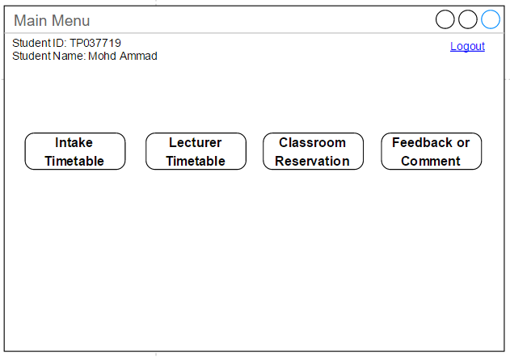

Figure .0 Student Main Menu

Figure 2.0 is the Student Main Menu, the user is able to click Intake Timetable, Lecturer Timetable, Classroom Reservation, and Feedback or Comment to go to those particular functions. Besides that, clicking logout button for logout then go to login interface.

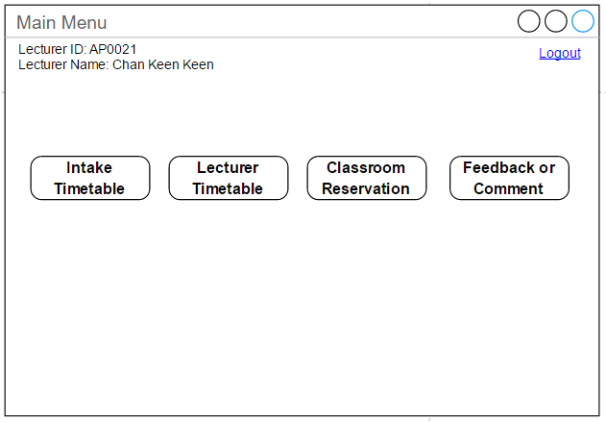

Figure .0 Lecturer Main Menu

Figure 3.0 is the Lecturer Main Menu, the user is able to click Intake Timetable, Lecturer Timetable, Classroom Reservation, and Feedback or Comment to go to those functions. Besides that, logout button is for logging out and go to login interface.User can click logout button to logout then go to login interface.

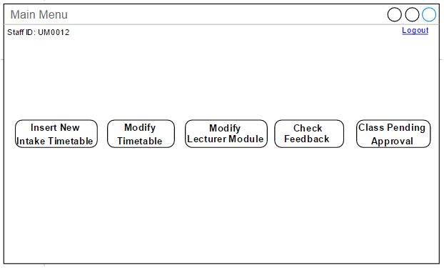

Figure .0 Admin Main Menu

Figure 4.0 is the Admin Main Menu, user is able to click Insert New Intake Timetable, Modify Timetable, Modify Lecturer Module, Check Feedback, and Class Pending Approval to go those functions. Besides that, click logout button for logout then go to login interface.

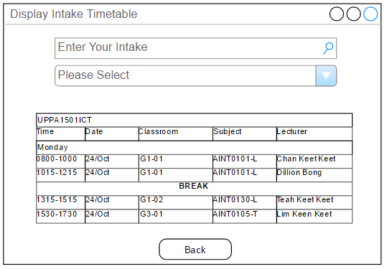

Figure .0 Display Intake Timetable

Figure 5.0 is the Display of Intake Timetable, user is able to search by the intake code, or select by the intake code from the dropdown list. Besides that, the back button is for returning to the previous interface.

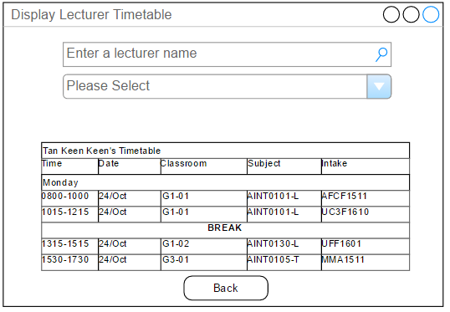

Figure .0 Display Lecturer Timetable

Figure 6.0 is the Display of Lecturer Timetable, user is able to search by the Lecturer Name, or select by the Lecturer Name from the dropdown list. Besides that, the back button is for going back to the previous interface.

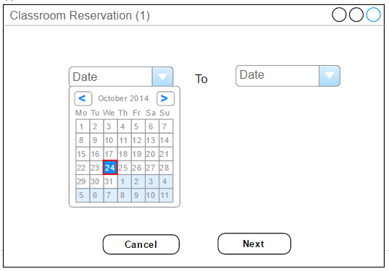

Figure .0 Classroom Reservation(1)

Figure 7.0 is Classroom Reservation (1), first user needs to select the date. Then, user is able to select the range of date. Moreover, without selecting the date user cannot proceed to the next process. Lastly, user clicks the next button to go to the next process.

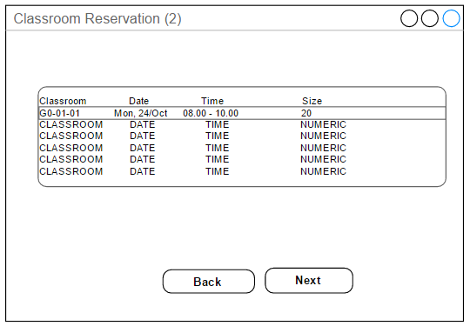

Figure .0 Classroom Reservation (2)

Figure 8.0 is Classroom Reservation (2), first user needs to select the classroom and clicks the next button. Next, back button is for going to previous page. Besides that, user must enter the classroom to proceed.

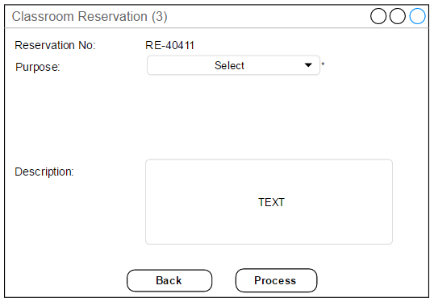

Figure .0 Classroom Reservation (3)

Figure 9.0 is Classroom Reservation (3), firstly user needs to select the purpose and enter the description and then click the next button. The purpose must be selected only can go to the next process.

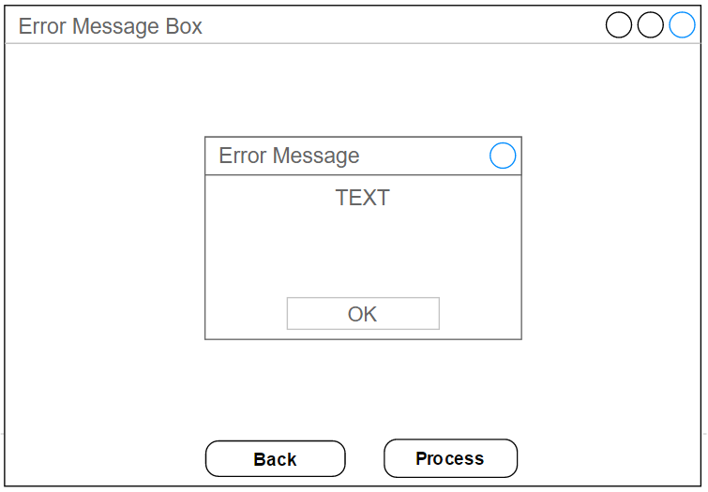

Figure .0 Error Message

Figure 10.0 is the Error Message box display, the user must click “OK” button to proceed to the next session.

Figure 11.0 is the Feedback or Comment function, user must select the Category and the Description. The cancel button is to return to user main menu. After the user typed the Description and selected the category, the user is able to click the submit button to submit it.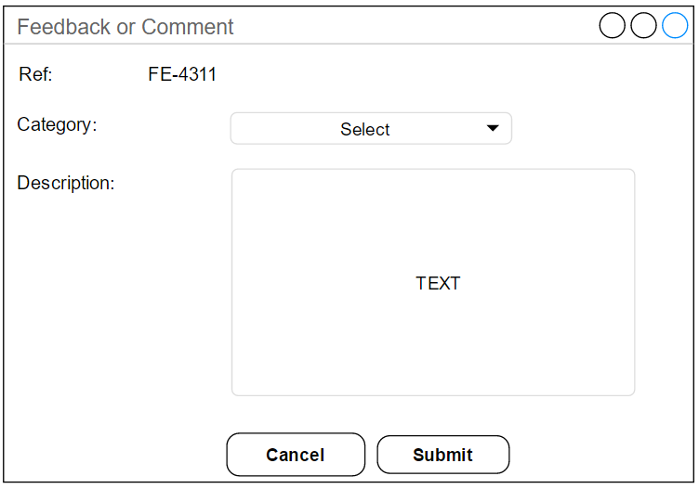

Figure .0 Feedback or Comment

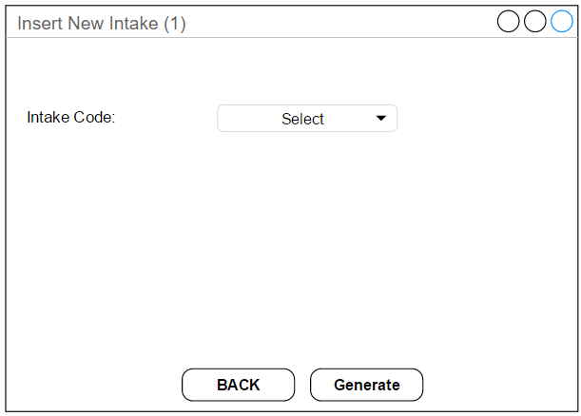

Figure .0 Insert New Intake (1)

Figure 12.0 is Insert New Intake (1), firstly the user must select the intake code then click Generate button. Besides that, the back button is used to navigate to previous interface.

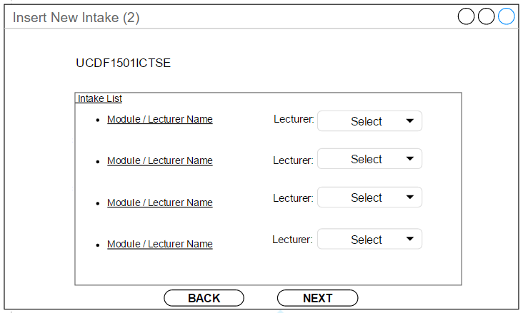

Figure .0 Insert New Intake (3)

Figure 13.0 is Insert New Intake (2), after the user selected the intake code, then clicks the generate button. Next, the Insert New Intake (2) will display the Module and the module of the lecturer currently teaching. Aside from the auto-assigned result, user can change the lecturer selection from the dropdown list. Furthermore, the back button is used to go to previous interface. Lastly, the user clicks next button to insert the new intake.

Figure 14.0 is the Class Pending Approval (1), this is the pending list of the classroom reservation. The user must choose the reservation then click the “Next” button to proceed. Besides that, the back button is used to go back to the previous interface.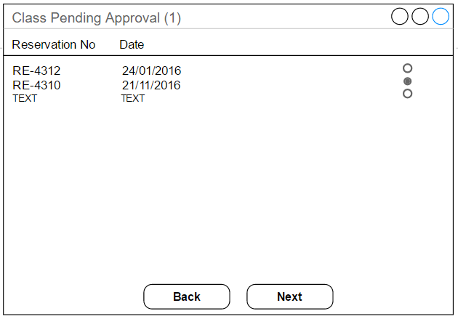

Figure .0 Class Pending Approval

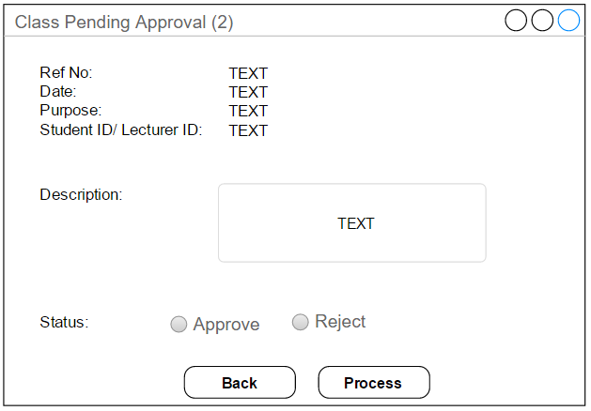

Figure .0 Class Pending Approval (2)

Figure 15.0 is the Class Pending Approval (2), it displays the details of the reservation pending user selected from the Class Pending Approval (1) interface. Next, the user can select the status whether the pending is approved or rejected. Besides that, the back button can be used to navigate to the previous interface. Lastly, the process button is to update the class pending.

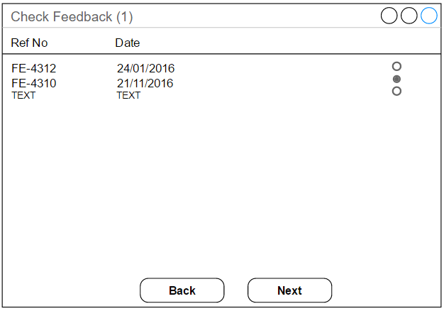

Figure .0 Check Feedback (1)

Figure 16.0 is Check Feedback (1), it displays the feedback list received from the other users. Firstly, the user must select the feedback then can only click the next button. The back button is for going to main menu interface.

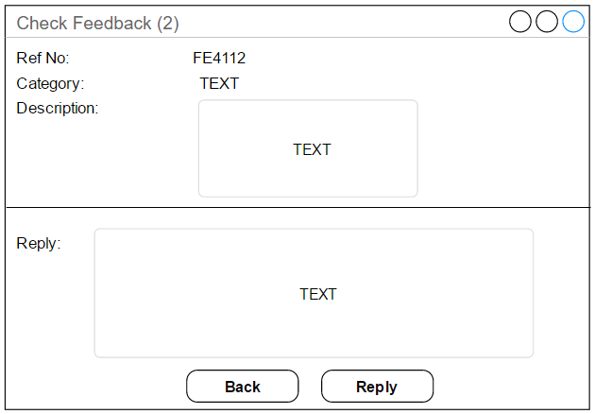

Figure .0 Check Feedback (2)

Figure 17.0 is Check Feedback (2), it is the feedback selected from the Check Feedback (1) and displaying its details. Besides that, the back button is for the user to return the previous page.

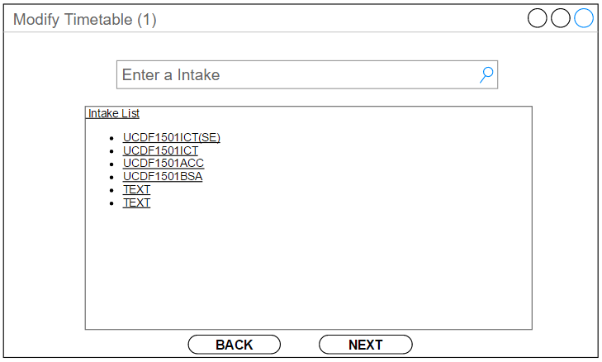

Figure .0 Modify Timetable (1)

Figure 18.0 is the Modify Timetable (1), user needs to enter an intake code into the search bar and thus the intake code list user entered will be displayed below the search bar. User needs to select the intake code in order to click the next button to proceed. Besides that, the back button is used to return to the previous interface.

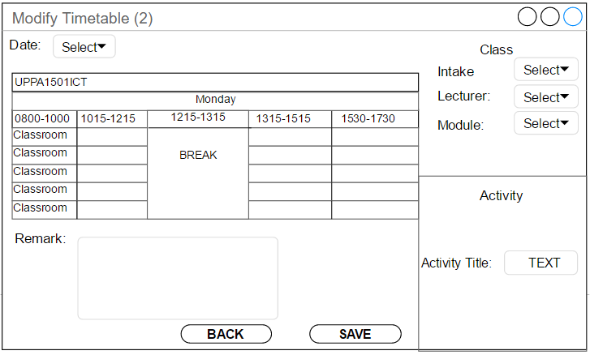

Figure .0 Modify Timetable (2)

Figure 19.0 is the Modify Timetable (2), user needs to select the date, classroom, intake, Lecturer, and Module to modify those details. Besides that, if it is activity, the program will show the activity title. The back button is for user to return to the previous interface. The user is also able to enter the remark of the class and save it.

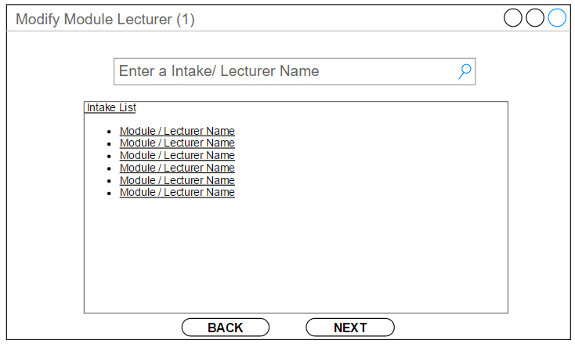

Figure .0 Modify Module Lecturer (1)

Figure 20.0 is the Modify Module Lecturer (1) interface. Firstly, the user needs to enter an intake code or lecturer name to search. Next, after the user entered the input, the box below the search bar will display a list of module and lecturer name for user selection and next button is clicked to modify it. The back button for user to return to the previous interface.

Figure 21.0 is the Modify Module Lecturer (2). Firstly, this interface will display the module code, intake of the user selected. Then the user is able to select the lecturer to edit the assignment of the teaching module.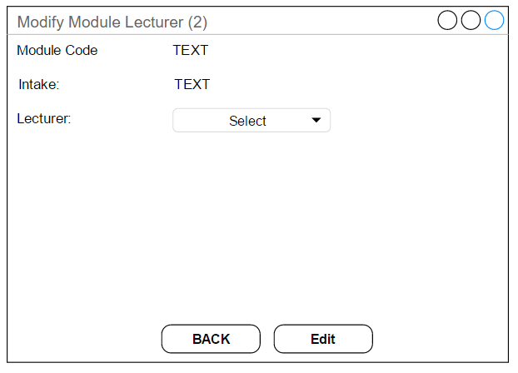

Figure .0 Modify Module Lecturer (2)

# 11.0 Preliminary Report Design

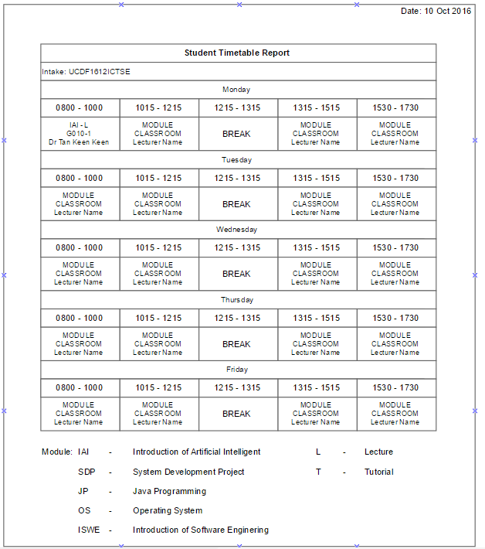

Figure 22.0 Student Timetable Report

Figure 22.0 is the student timetable report, this report consists of intake code, module classroom, time, and date. Firstly, below the “Monday” there is the sample output of the timetable with module, classroom, and time. Besides that, the time 1215 to 1315 is the lunch break. Lastly, this report is design for the student to view the intake’s timetable with module, lecturer name, and classroom.

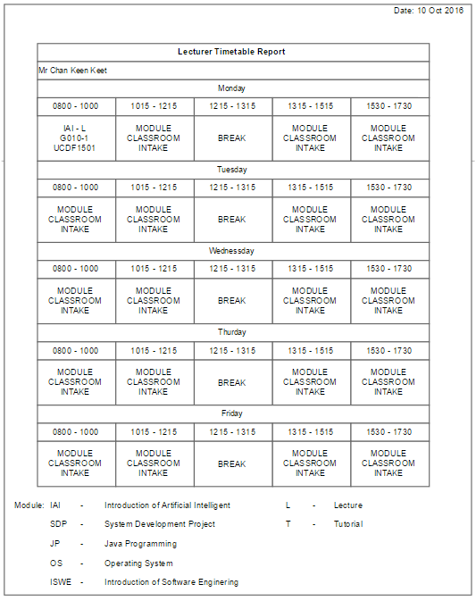

Figure .0 Lecturer Timetable Report

Figure 23.0 is the Lecturer Timetable report. Firstly, the lecturer timetable report consists of Date, Lecturer Name, time, Module ID, Module Name, Classroom, and Intake code. Lastly, this report is design for the lecturer to view the lecturer’s timetable with module, student’s intake, lecturer name, and classroom.

Figure 24.0 is the Lecturer report, consists of Lecturer Name, Intake, time, module of the lecturer teach. Next, this report is showing the modules of the lecturer teaching, the time of the class that lecturer teaching, and the total of time, intake and module.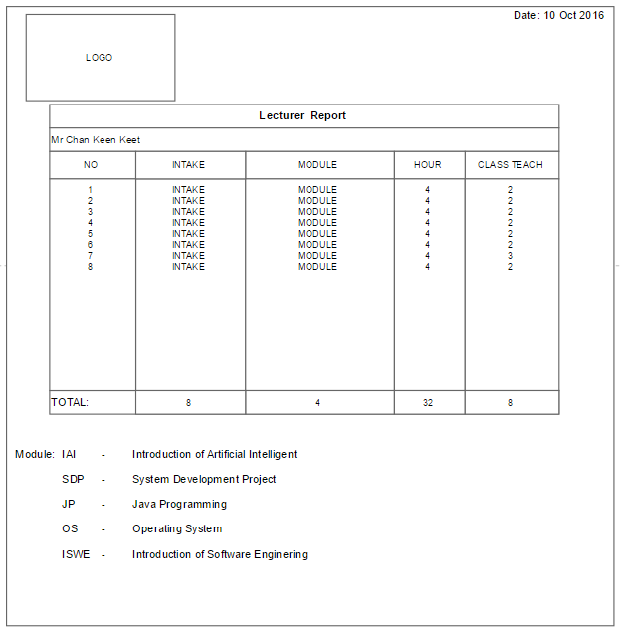

Figure .0 Lecturer Report

# 12.0 Test Plan

**Sample Test Case Template**

|  |  |  |  |  |  |  |
| --- | --- | --- | --- | --- | --- | --- |
| **Test Case#** | **Test Title** | **Test Procedures** | **Test Data** | **Expected Result** | **Actual Result** | **Remarks** |
| 1 | Login Button with valid data in Login interface | Enter the valid Username and Password then click “LOGIN” button | Username: Admin  Password: asd123 | Go to Main Menu interface |  |  |
| 2 | Login Button with invalid data in Login interface | Enter the invalid Username or Password then click “LOGIN” button | Username: Admins  Password: asd123s | Error message notifying the user entered incorrect username or password |  |  |
| 3 | Intake Timetable Button in Login interface | Click the “Intake Timetable” button |  | Go to Intake Timetable interface |  |  |
| 4 | Lecturer Timetable Button in Login interface | Click the “Lecturer Timetable” button |  | Go to Lecturer Timetable interface |  |  |
| 5 | Exit button in Login interface | Click the “Exit” button |  | Close the program |  |  |
| 6 | Back button in View Intake Timetable | Click the “Back” button |  | Able to go back to user Main |  |  |
| 7 | Search by intake in Intake Timetable | Enter the intake code in the “Search Bar” to search the timetable | Intake Code: UCDF1501ICTSE | Display intake timetable searched by user |  |  |
| 8 | Select by intake in Intake Timetable | Choose from the dropdown list |  | Display the timetable chosen by user |  |  |
| 9 | Back button in Lecturer Timetable | Click the “Back” button |  | Able return back to user Main Menu or Login Page |  |  |
| 10 | Search by Lecturer Name in Lecturer Timetable | Enter the lecturer name in the “Search Bar” to search the lecturer timetable | Lecturer Name: CHAN KEEN KEET | Display the lecturer’s timetable searched by user |  |  |
| 11 | Select by Lecturer Name in Lecturer Timetable | Choose from the dropdown list |  | Display the lecturer’s timetable chosen by user |  |  |
| 12 | Logout button in Student Main Menu | Click the “Logout” button |  | Go to the “login” interface |  |  |
| 13 | Intake Timetable button in Student Main Menu | Click the “Intake Timetable” button | Intake Code: UCDF1501ICTSE | Go to “Course Timetable” interface |  |  |
| 14 | Lecturer Timetable button in Student Main Menu | Click the “Lecturer Timetable” button | Lecturer Name: CHAN KEEN KEET | Go to “Lecturer Timetable” interface |  |  |
| 15 | Classroom Reservation button in Student Main Menu | Click the “Classroom Reservation” button |  | Go to the “Classroom Reservation” interface |  |  |
| 16 | Feedback or Comment button in Student Main Menu | Click the “Feedback or Comment” button |  | Go to “Feedback or Comment” interface |  |  |
| 17 | Logout button in Student Main Menu | Click the “Logout” button |  | Go to the “login” interface |  |  |
| 18 | Lecturer Timetable button in Lecturer Main Menu | Click the “Lecturer Timetable” button | Intake Code: UCDF1501ICTSE | Go to “Lecturer Timetable” interface |  |  |
| 19 | Intake Timetable button in Lecturer Main Menu | Click the “Intake Timetable” button | Lecturer Name: CHAN KEEN KEET | Go to “Course Timetable” interface |  |  |
| 20 | Classroom Reservation button in Lecturer Main Menu | Click the “Classroom Reservation” button |  | Go to the “Classroom Reservation” interface |  |  |
| 21 | Feedback or Comment button in Lecturer Main Menu | Click the “Feedback or Comment” button |  | Go to “Feedback or Comment” interface |  |  |
| 22 | Logout button in Lecturer Main Menu | Click the “Logout” button |  | Go to the “login” interface |  |  |
| 23 | Insert New Intake Timetable button in Admin Main Menu | Click the “Insert New Intake Timetable” button |  | Go to the “Insert New Intake Timetable” interface |  |  |
| 24 | Modify Timetable button in Admin Main Menu | Click the “Modify Timetable” button |  | Go to“Modify Timetable” interface |  |  |
| 25 | Modify Lecturer Module button in Admin Main Menu | Click the “Modify Lecturer Module” button |  | Go to “Modify Lecturer Modify” interface |  |  |
| 26 | Class Pending Approval button in Admin Main Menu | Click the “Class Pending Approval” button |  | Go to the “Class Pending Approval” interface |  |  |
| 27 | Check Feedback button in Admin Main Menu | Click the “Check Feedback” button |  | Go to the “Check Feedback” interface |  |  |
| 28 | Function in Feedback or Comment interface | Choose the “Category” and enter the “Description” then Click “Submit” button | Description: Why I cannot find my intake timetable? | The feedback will be sent |  |  |
| 29 | Invalid submit in Feedback or Comment interface | Click the “Submit” button do not entered “Description” and choose “Category” |  | Error message notifying the form cannot be empty |  |  |
| 30 | Cancel button in Feedback or Comment | Click the “Cancel” button |  | Go to “Main Menu” interface |  |  |
| 31 | Select date in Classroom Reservation (1) | Click the “Date” and select the date then Click the “Next” button |  | Go to “Reserve Classroom (2)” interface |  |  |
| 32 | Cancel button in Classroom Reservation (1) | Click the “Cancel” button |  | Go to user “Main Menu” interface |  |  |
| 33 | Date validation in Classroom Reservation (1) | Did not select “Date” then Click the “Next” button |  | Error message notifying the date must be selected then only can process, cannot be empty |  |  |
| 34 | Time Slot validation in Classroom Reservation (2) | Did not select anything from “Time Slot” then click the “Next” button |  | Error message notifying the time slot, cannot be empty |  |  |
| 35 | Next button in Classroom Reservation (2) | Selected the “Time Slot” then click the “Next” button |  | Go to the “Reserve Classroom (3)” interface |  |  |
| 36 | Back button in Classroom Reservation (2) | Click the “Back” button |  | Go to user “Reserve Classroom (1)” interface |  |  |
| 37 | Process button in Classroom Reservation (3) | Selected the “Purpose” from the dropdown list, and entered “Description” then click “Process” button | Description: Extra class for chapter 5 | Go to the “Main Menu” and the classroom request is sent |  |  |
| 38 | Back button in Classroom Reservation (3) | Click the “Back” button |  | Go to user “Reserve Classroom (2)” interface |  |  |
| 39 | Validation in Classroom Reservation (3) | Did not select the “Purpose” from the dropdown list, and entered “Description” then click “Process” button |  | Error message notifying the form must be filled |  |  |
| 40 | Error Message box | Click the “OK” button |  | Close the error Message box |  |  |
| 41 | Next button in Check Feedback (1) | Selected the feedback from the feedback then click “Next” button |  | Go to “Check Feedback (2)” interface |  |  |
| 42 | Validation in Check Feedback (1) | Did not select the feedback from the feedback then click “Next” button |  | Error message notifying the feedback must be selected |  |  |
| 43 | Back button in Check Feedback (1) | Click the “Back” button |  | Go to “Main Menu” interface |  |  |
| 44 | Reply button in Check Feedback (2) | Entered the text in the “Reply” text box then click “Reply” button | Reply: We will fix the problem | Go to “Check Feedback (1)” interface |  |  |
| 45 | Validation in Check Feedback (2) | Did not entered the text in the “Reply” text box then click “Reply” button |  | Error message notifying the text box must be entered |  |  |
| 46 | Back button in Check Feedback (2) | Click the “Back” button |  | Go to “Check Feedback (1)” interface |  |  |
| 47 | Search intake/Lecturer Name in Modify Lecturer Module (1) | Entered the text in the search bar then press “Enter” button in keyboard | Intake Code: UCDF1501ICTSE  Lecturer Name: Chan Keen Keet | Display the “Module/Lecturer Name” in the Intake List |  |  |
| 48 | Select intake/Lecturer Name in Modify Lecturer Module (1) | Selected the “Module/Lecturer” in the Intake List then click the “Next” button |  | Go to “Modify Module Lecturer (2)” interface |  |  |
| 49 | Validation in Modify Lecturer Module (1) | Did not Select the “Module/Lecturer” in the Intake List then click the “Next” button |  | Error message notifying the “Module/Lecturer Name” must be selected |  |  |
| 50 | Back button in Modify Lecturer Module (1) | Click the “Back” button |  | Go to “Main Menu” interface |  |  |
| 51 | Modify lecturer in Modify Lecturer Module (2) | Select the “Lecturer” from dropdown list then “Edit” button |  | The module of lecturer teach will be edited and go to the “Main Menu” interface |  |  |
| 52 | Back button in Modify Lecturer Module (2) | Click the “Back” button |  | Go to “Modify Lecturer Module (1)” interface |  |  |
| 53 | Next button in Class Pending Approval (1) | Selected the reservation then click “Next” button |  | Go to “Class Pending Approval (2)” interface |  |  |
| 54 | Validation Class Pending Approval (1) | Did not select the reservation then click “Next” button |  | Error message notifying the feedback must be selected |  |  |
| 55 | Back button in Class Pending Approval (1) | Click the “Back” button |  | Go to “Main Menu” interface |  |  |
| 56 | Select the Status in Class Pending Approval (2) | Selected the “Status” then click the “Process” button |  | The class request will be approved or rejected then go to the “Main Menu” interface |  |  |
| 57 | Validation in Class Pending Approval (2) | Did not select the “Status” then click the “Process” button |  | Error message notifying the feedback must be selected |  |  |
| 58 | Back button in Class Pending Approval (2) | Click the “Back” button |  | Go to “Class Pending Approval (1)” interface |  |  |
| 59 | Search by intake in Modify Timetable (1) | Enter the intake code in the search bar then press “Enter” in the keyboard for search | Intake Code: UCDF1501ICTSE | The “Intake List” will display the intake code |  |  |
| 60 | Select by intake in Modify Timetable (1) | Selected the intake then click the “Next” button |  | Go to the “Modify Timetable (2)” interface |  |  |
| 61 | Next button in Modify Timetable (1) | Did not select the intake then click the “Next” button |  | Error message notifying the intake must be selected |  |  |
| 62 | Back button in Modify Timetable (1) | Click the “Back” button |  | Go to the “Main Menu” interface |  |  |
| 63 | Date validation in Modify Timetable (2) | Selected the invalid date or did not select the date |  | Error message notifying the date must select or select the valid date |  |  |
| 64 | Duplication of lecturer in Modify Timetable (2) | Selected a duplicated lecturer or did not select a lecturer |  | Error message notifying the lecturer must be selected or select the valid lecturer |  |  |
| 65 | Validation in Modify Timetable (2) | Did not select the intake and module |  | Error message notifying that the intake and module must be selected |  |  |
| 66 | Edit module in Modify Timetable (2) | For class, selected date, time slot, intake, lecturer, and module then click the “Save” button |  | The timetable will be edited and go to the “Main Menu” interface |  |  |
| 67 | Activity in Modify Timetable (2) | For activity, selected date then click the “Save” button |  | The timetable will be edited and go to the “Main Menu” interface |  |  |
| 68 | Back button in Insert New Intake (1) | Click the “Back” button |  | Go to “Main Menu” interface |  |  |
| 69 | Generate in Insert New Intake (1) | Selected the “Intake Code” then click “Generate” button |  | The system will auto generate the timetable for student and lecturer then go to “Insert New Intake (2)” interface |  |  |
| 70 | Validation in Insert New Intake (1) | Did not select the “Intake Code” then click “Generate” button |  | Error message notifying the intake code must be selected |  |  |
| 71 | Back in Insert New Intake (2) | Click the “Back” button |  | Go to “Insert New Intake (1)” interface |  |  |
| 72 | Change lecturer module in Insert New Intake (2) | Select the “Lecturer” to assign module to lecturer then click “Next” button |  | Change Lecturer of auto assign then go to “Main Menu” |  |  |

# 13.0 Conclusion

## 13.1 Perceived Assumption

The proposed system is developed based on assumptions that are expected by the development team. One of the assumption is that proposed system has the capability of retrieving shared database from other system. For example, student details, lecturer details and classroom details are all retrieved from shared database of other system in APU. The system is also able to receive the user's feedback and comment and it will be stored into another shared database that can be accessed by another department.

Furthermore, this system only can generate classes from 8.30 am to 5.30 pm. Lecturer or student can only reserve or request classes from 8.30 am to 5.30 pm. The time slot is fixed where each time slot is 2 hours period. The classes consists of computer labs which can fit 30 students each labs, engineering labs that can fit 20 students each class, and auditoriums that can fit 100 students eat. After 5.30 pm, the university is still open but no classes can be reserve after 5.30 pm.

Another assumption is the login authorizations of the users are given during the enrollment and employment to APU. Example of users type are admin, lecturer and student. The login ID and password of the user is generated by a different department within APU. Users are also able to search for specific lecturer timetables and specific intake timetable without logging into the timetable scheduling system.

Another assumption is this timetable scheduling system has the capability to validate the class size of classrooms whether it matches the number of students, to detect duplication of intake or lecturer, and clashing between current classes, reserved classes, and student activities. Validations are implemented to prevent errors occurs, to obtain accurate and consistent analysis of information and able to produce accurate report.

## 13.2 Perceived Limitations

There are limitations can be found in this timetable scheduling system as well. One of the limitation of this system is the users are unable to create nor register their personal login account. The user's account are given when they enrolled or employed into APU. The user login ID and password are created by different department to control and keep track the number of user in the system.

Besides that, another limitation in this timetable scheduling system is that all the time slots are having fixed duration. When student or lecturer is attempting to reserve a classroom for classes or activities, the user can only request for the time slot that is fixed by APU. This causes the request of classroom reservation from the user are not flexible. It also has a list of classrooms for the user to choose based on the time slot chosen. When the request is rejected, user will have to choose another classroom in the chosen time slot.

Furthermore, this timetable scheduling system is unable to search or view the timetable of the next two week. It can view or search the timetable of the current week and the following week only, the timetable of the week after is not available for users. This causes students and lecturers unable to manage or plan their time further ahead. For example, students and lecturers are unable to view for the classes or activities which are two or three weeks after.

Moreover, the system is also a offline timetable scheduling system where it is can be only accessed by user through using the system itself. It cannot be accessed through internet. This may causes users cannot have full optimization of the timetable scheduling system unless the user are in APU.

## 13.3 Perceived Enhancement

To further enhance the timetable scheduling system, the development team has decided to increase the capabilities and efficiency of the system. Based on the limitation above, the timetable scheduling system can be enhance and improve by having a functions for lecturer and students to modify the password themselves in the timetable scheduling system. This can have higher security for the users where only they can know their own password.

Another enhancement for the timetable scheduling system, the system can be improved by converting to a web based system that can be accessed easily by users through web browser or smartphone. This can help the system to be more efficient and increase the convenience for users. By converting to a web based system, information can be get easily and timetable can be viewed by user whenever there is internet in the area.

Besides that, the system can also be enhanced and improved by enable users to search and view the timetables of one month. This can allow students and lecturers to view the timetable and plan ahead for the next month. It can gives more choice for lecturers and students to reserve classes.

# 14.0 References

**ERD**

https://www.lucidchart.com/pages/ER-diagram-symbols-and-meaning

http://jcsites.juniata.edu/faculty/rhodes/dbms/ermodel

http://users.csc.calpoly.edu/~jdalbey/205/Lectures/HOWTO-ERD.html

**Pseudocode**

http://users.csc.calpoly.edu/~jdalbey/SWE/pdl_std.html

http://apcs.csie.ntnu.edu.tw/www/ap/PseudoCode.pdf

http://www.unf.edu/~broggio/cop3530/3530pseu.htm

# 15.0 Appendix

**Minutes Meeting: No 1**

|  |  |  |
| --- | --- | --- |
| Date | Venue | Attendance (Group member’s name) |
| 18/10/2016 | ENTP3 | Chan Keen Keet TP037812  Ng Wen Yang TP037400  Lee Kang Wei TP037224 |

What have been done?

1. Planning of the topic, planning of methodology to be used, planning of project scope, objectives and solutions.

What is currently being done?

1. Introduction of documentation, project background, problem and solutions, project scope and objectives.

What will be done?

1. Methodology, Gantt Chart, System Hierarchy Chart and Context Diagram.

Other remarks/issue: All the work are to be done accordingly by group members and to be discussed and check again in the next meeting.

**Minutes Meeting: No 2**

|  |  |  |
| --- | --- | --- |
| Date | Venue | Attendance (Group member’s name) |
| 20/10/2016 | ENTP3 | Chan Keen Keet TP037812  Ng Wen Yang TP037400  Lee Kang Wei TP037224 |

What have been done?

1. Introduction of documentation with chosen educational field, project background of the chosen university, problems found in the university system and solutions to solve the problems, project scope of the chosen university, and the objectives of the project.

What is currently being done?

1. Project Gantt Chart, Context Diagram and System Development Methodology.

What will be done?

1. System Hierarchy Chart, DFD Diagrams and Data Flow Diagrams.

Other remarks/issue: All the work are to be done accordingly by group members based on the chosen topics and it is to be discussed again in the next meeting.

**Minutes Meeting: No 3**

|  |  |  |
| --- | --- | --- |
| Date | Venue | Attendance (Group member’s name) |
| 24/10/2016 | ENTP3 | Chan Keen Keet TP037812  Ng Wen Yang TP037400  Lee Kang Wei TP037224 |

What have been done?

1. Project Gantt Chart, Context Diagram and System Development Methodology are done. System Development Methodology is done based on the Project Gantt Chart.

What is currently being done?

1. System Hierarchy Chart, DFD Diagrams and Pseudocode.

What will be done?

1. Data Dictionary, Entity Relationship Diagram, Screen Design and User Manual.

Other remarks/issue: All the work are to be done accordingly by group members based on the chosen topics and it is to be discussed again in the next meeting. For the issue, the group has decided to add level 1 DFD diagram based on the Pseudocode.

**Minutes Meeting: No 4**

|  |  |  |
| --- | --- | --- |
| Date | Venue | Attendance (Group member’s name) |
| 4/11/2016 | ENTP3 | Chan Keen Keet TP037812  Ng Wen Yang TP037400  Lee Kang Wei TP037224 |

What have been done?

1. System Hierarchy Chart, DFD Diagrams and Pseudocode are done. Level 1 DFD diagram has been added as well.

What is currently being done?

1. Data Dictionary, Entity Relationship Diagram, Preliminary Screen Design.

What will be done?

1. Preliminary Report Design, Test Plan, Conclusion, References and Appendix

Other remarks/issue: All the work are to be done accordingly by group members based on the chosen topics and it is to be discussed again in the next meeting. For the issue, the Entity Relationship Diagram, the group has decided to change to Crow’s Feet Notation method. There are also changes for the Preliminary Screen Design.

**Minutes Meeting: No 5**

|  |  |  |
| --- | --- | --- |
| Date | Venue | Attendance (Group member’s name) |
| 7/11/2016 | ENTP3 | Chan Keen Keet TP037812  Ng Wen Yang TP037400  Lee Kang Wei TP037224 |

What have been done?

1. Data Dictionary, Entity Relationship Diagram, Preliminary Screen Design.

What is currently being done?

1. Data Dictionary, Entity Relationship Diagram, Preliminary Screen Design.

What will be done?

1. Finalize and print the documentation and ready to be submitted.

Other remarks/issue: All the work are to be done accordingly by group members based on the chosen topics and documentation is to be prepared.